 **Assignment Cover Sheet**

|  |  |  |
| --- | --- | --- |
| **Student Information (For group assignment, please state names of all members)** | | **Grade/Marks** |
| **Name** | **ID** |  |
| Adrian Foo Jun Wei | B1600693 |  |
| Daenise Tan Hooi Qing | B1601153 |  |
|  |  |  |
|  |  |  |
|  |  |  |
|  |  |  |
|  |  |  |

|  |  |  |
| --- | --- | --- |
| **Module/Subject Information** | | **Office Acknowledgement** |
| **Module/Subject Code** | BIT 102 |  |
| **Module/Subject Name** | Internet Concepts and Infrastructure |  |
| **Lecturer/Tutor/Facilitator** | Naline Shanmugam |  |
| **Due Date** | 18.07.2016 |  |
| **Assignment Title/Topic** | Assignment 2 |  |
| **Intake (where applicable)** | May 2016 |  |
| **Word Count** |  | **Date/Time** |

**Declaration**

* I/We have read and understood the Programme Handbook that explains on **plagiarism**, and I/we testify that, unless otherwise acknowledged, the work submitted herein is entirely my/our own.
* I/We declare that no part of this assignment has been written for me/us by any other person(s) except where such collaboration has been authorized by the lecturer concerned.
* I/We authorize the University to test any work submitted by me/us, using text comparison software, for instances of plagiarism. I/We understand this will involve the University or its contractors copying my/our work and storing it on a database to be used in future to test work submitted by others.

Note: 1) The attachment of this statement on any electronically submitted assignments will be deemed to have the same authority as a signed statement.

2) The Group Leader signs the declaration on behalf of all members.

|  |  |
| --- | --- |
| Signature: | Date: |
| E-mail: |  |

|  |
| --- |
| **Feedback/Comments\*** |
| **Main Strengths** |
|  |
|  |
|  |
|  |
|  |
|  |
|  |
| **Main Weaknesses** |
|  |
|  |
|  |
|  |
|  |
|  |
|  |
| **Suggestions for improvement** |
|  |
|  |
|  |
|  |
|  |
|  |
|  |

|  |  |
| --- | --- |
|  | **Student acknowledge feedback/comments** |
|  |
| Grader’s signature | Student’s signature: |
| Date: | Date: |

Note:

1. A soft and hard copy of the assignment shall be submitted.
2. The signed copy of the assignment cover sheet shall be retained by the marker.
3. If the Turnitin report is required, students have to submit it with the assignment. However, departments may allow students up to **THREE** (3) working days after submission of the assignment to submit the Turnitin report. The assignment shall only be marked upon the submission of the Turnitin report.

*Use additional sheets if required.

**URL**: www.helphoroscopes.com.my

**Target Audience**:

Young and connected female that interested in lifestyle, health, love, career and entertainment information and their age are mainly from 13 to 40.

**Purpose:**

Provide information for people who believe and interested in horoscope. According to horoscope, it can show a related person’s basic characteristics, preference, flaws and fears. It can also show the strengths and weakness of the twelve horoscopes and also about their health, love, money and career.

**Print screen of webpage**

**Google chrome**

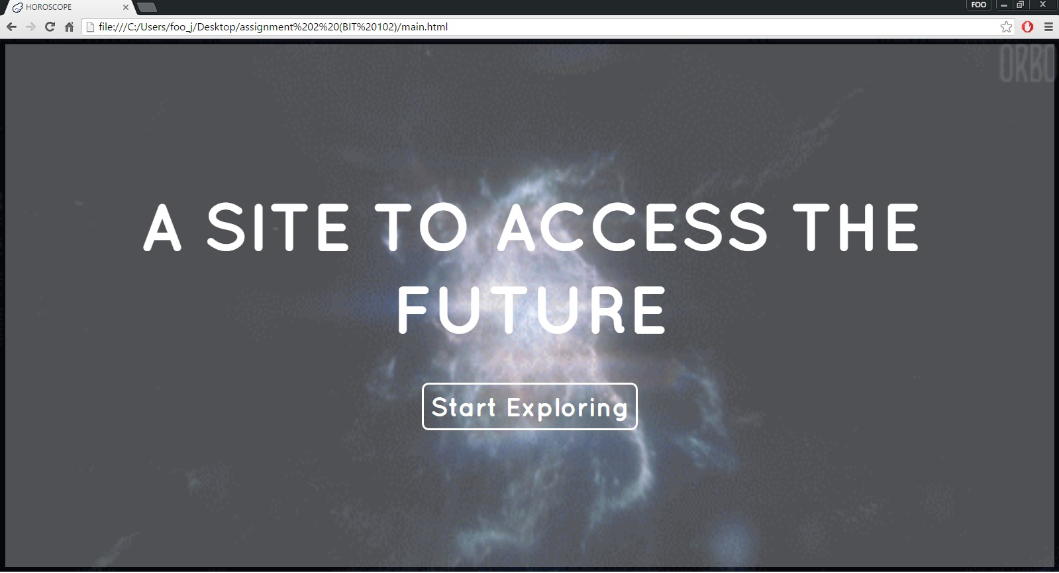

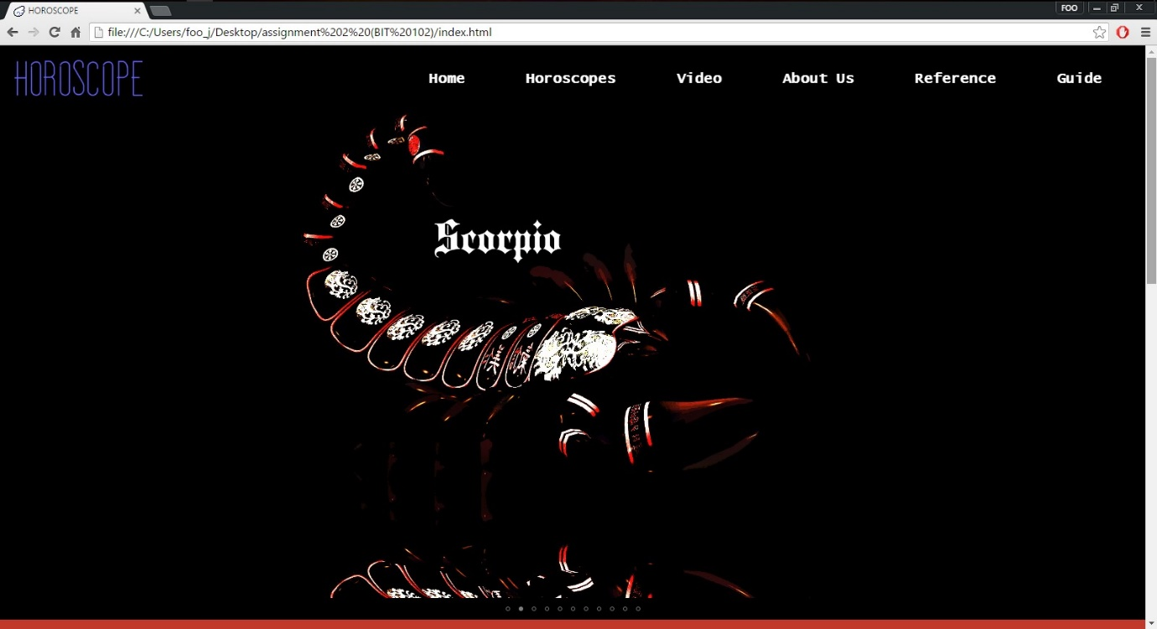

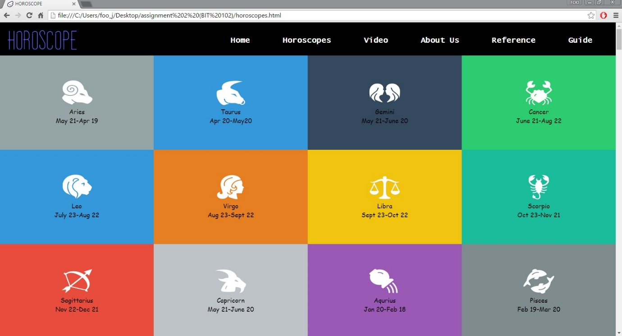

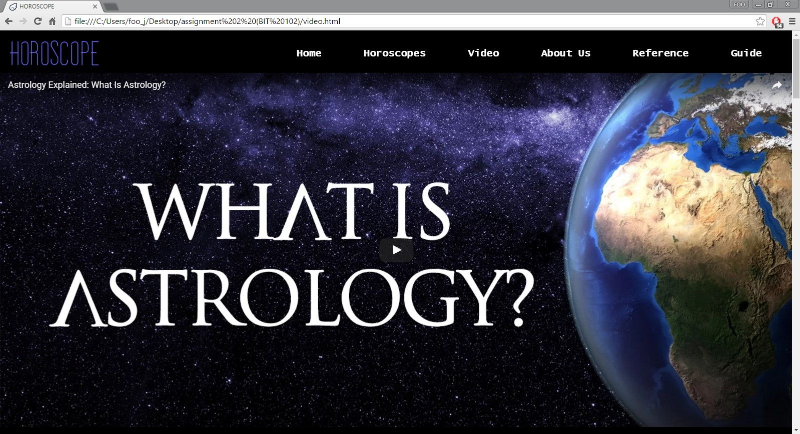

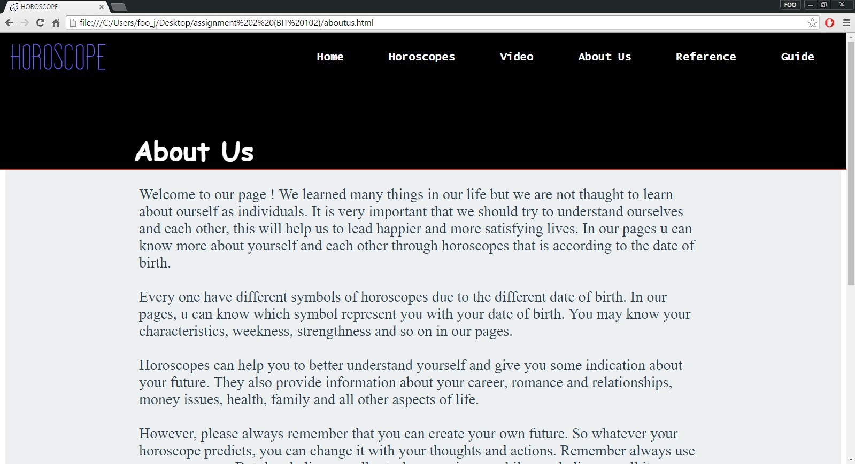

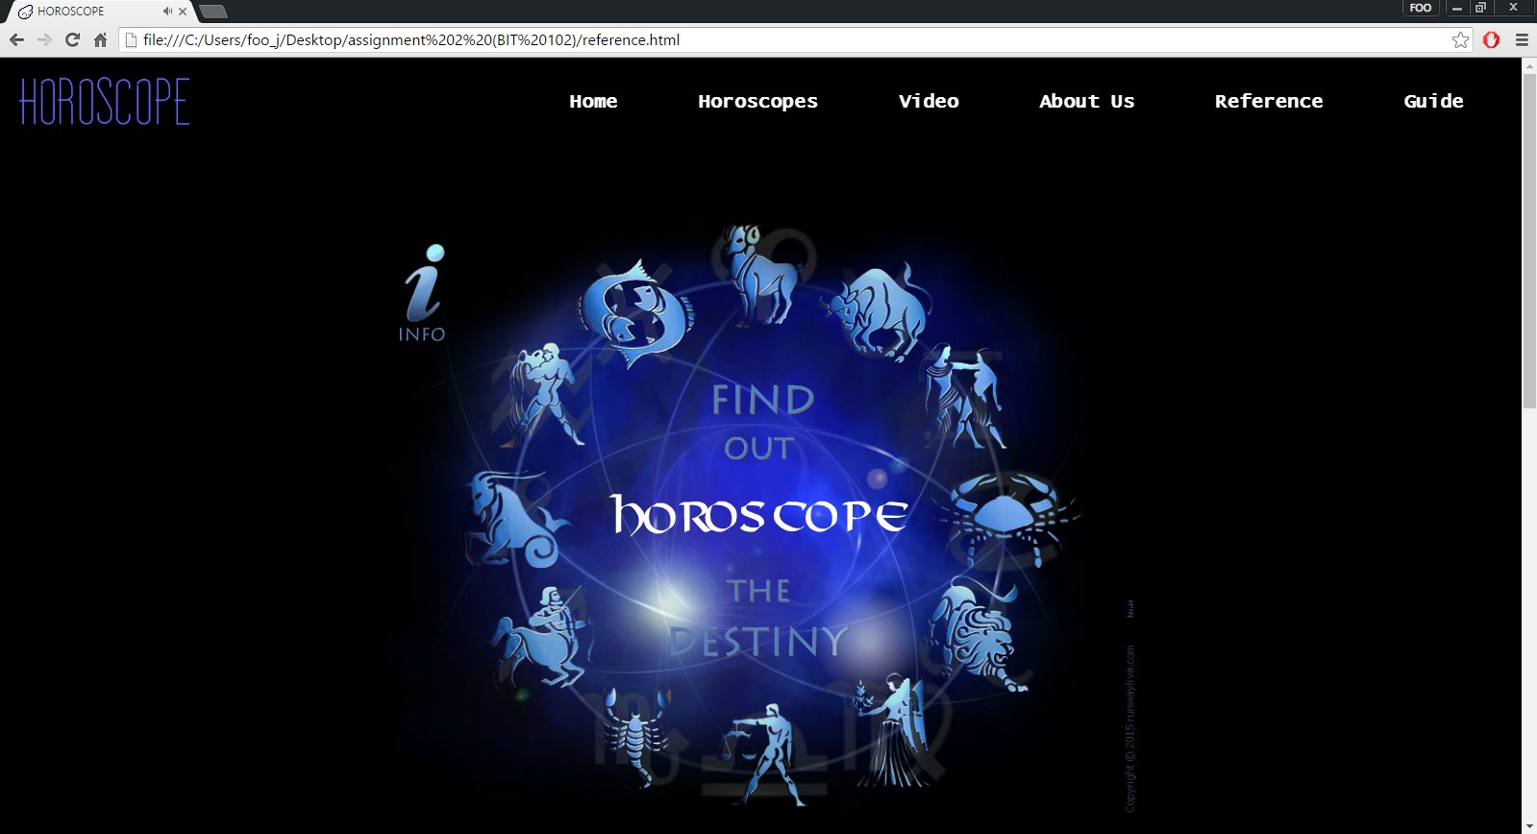

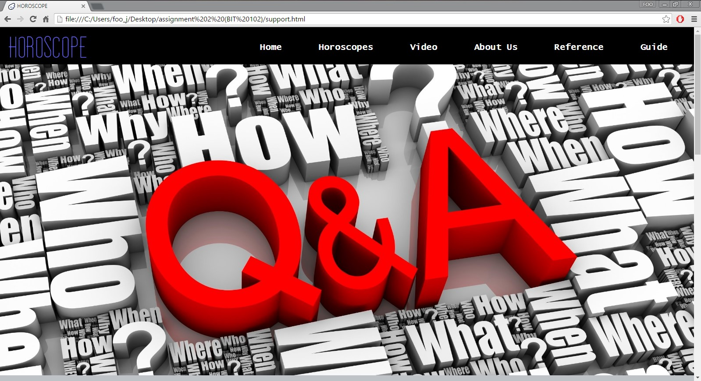

**Print screen of validation reports**

**Main page (css)**

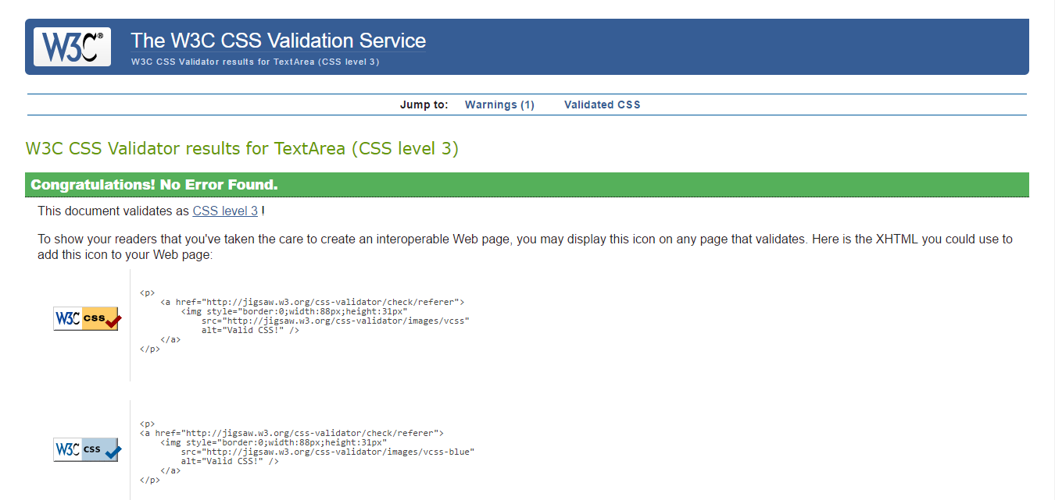

**Main page (Html)**

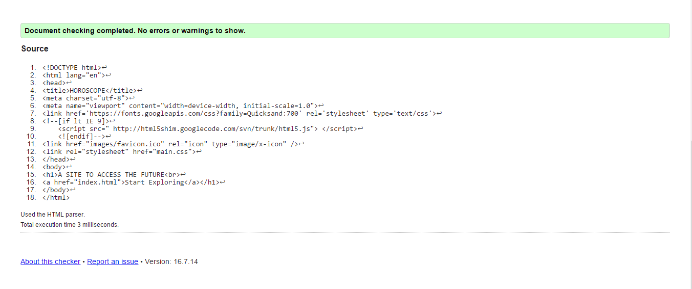

**Index (css)**

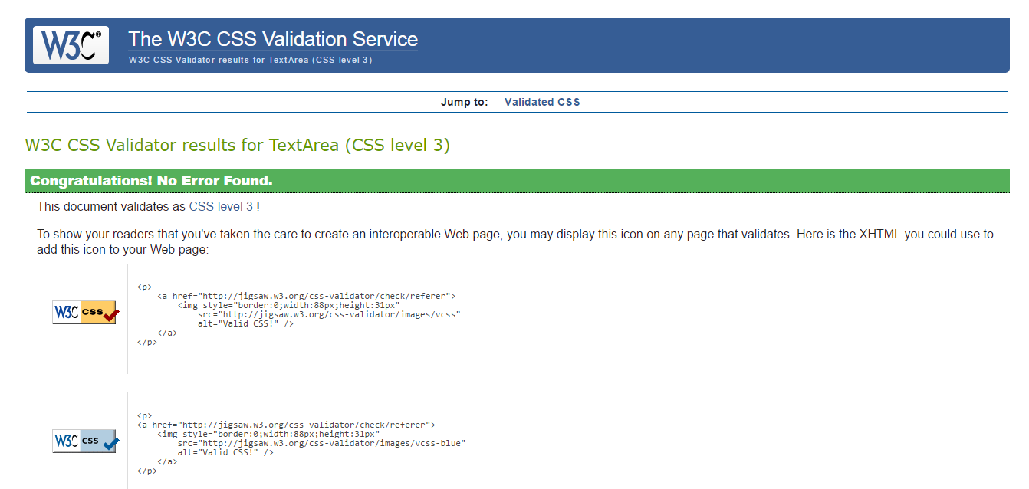

**Index (Html)**

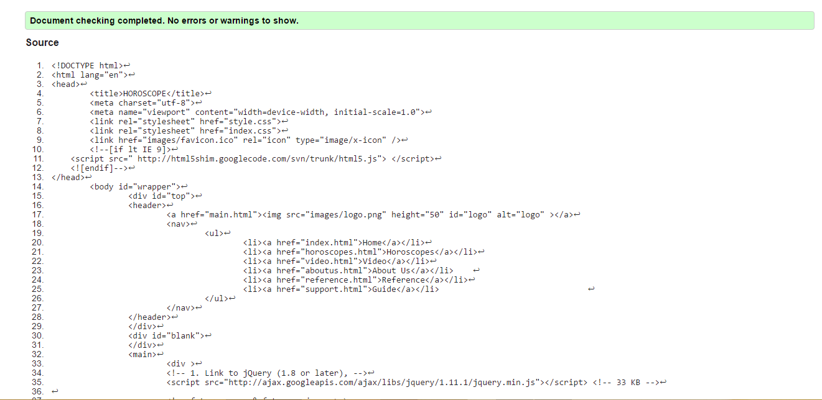

**Horoscopes (css)**

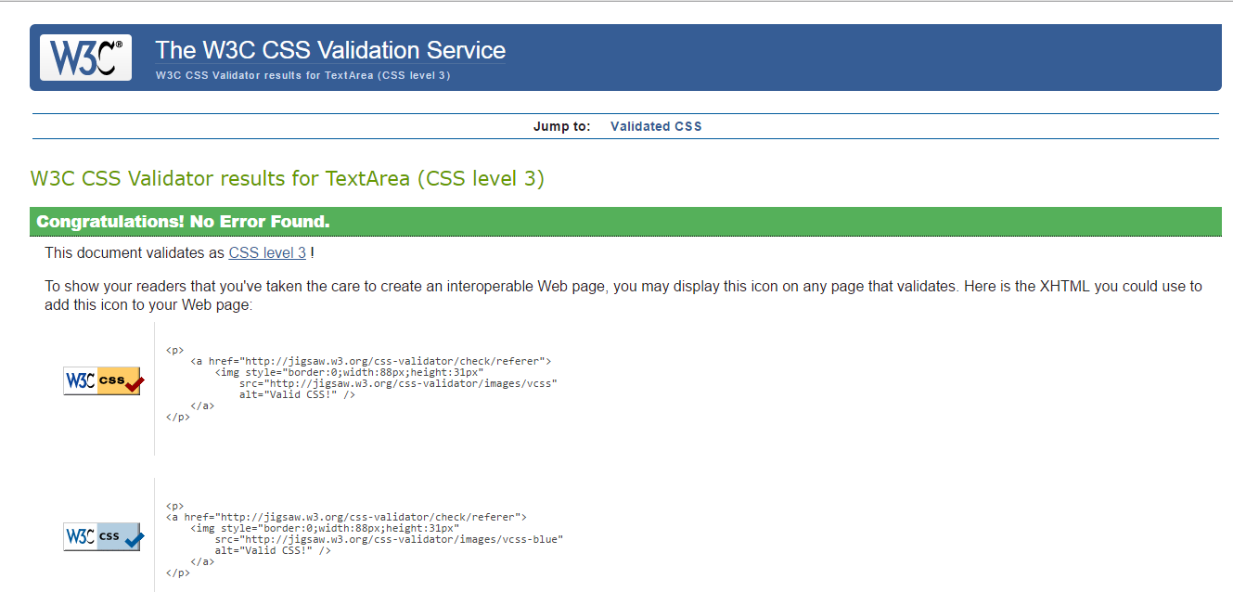

**Horoscopes (Html)**

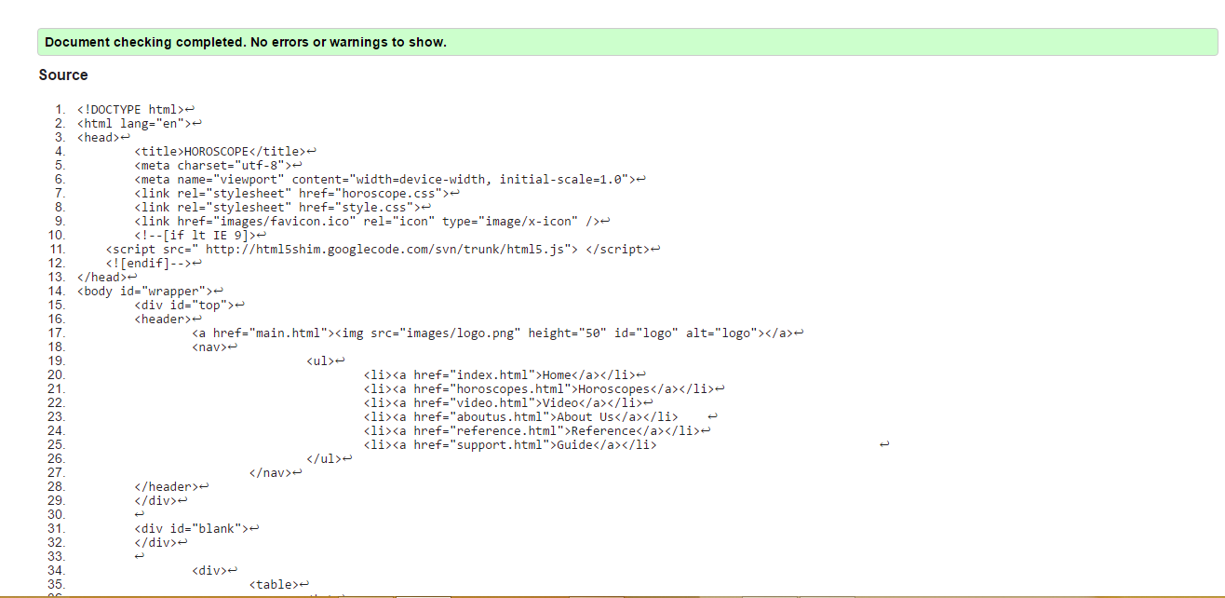

**Video (css)**

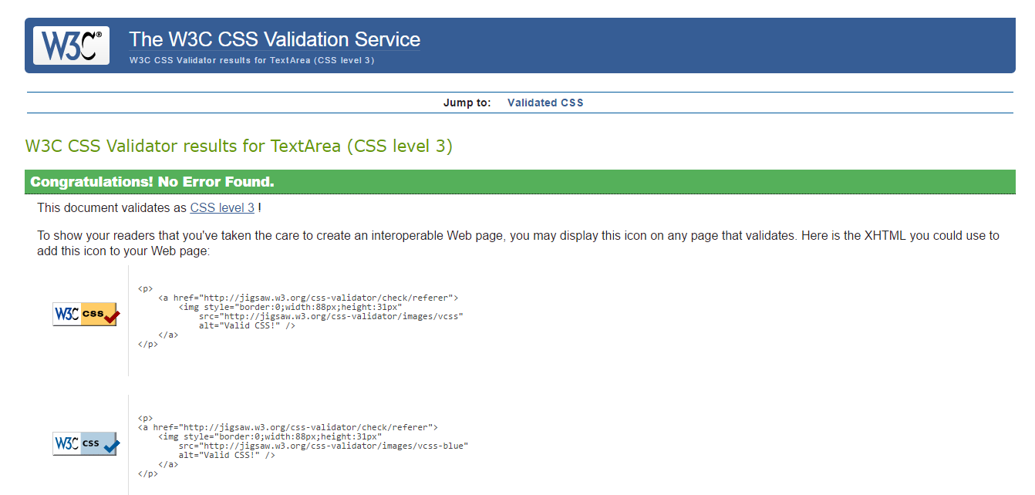

**Video (Html)**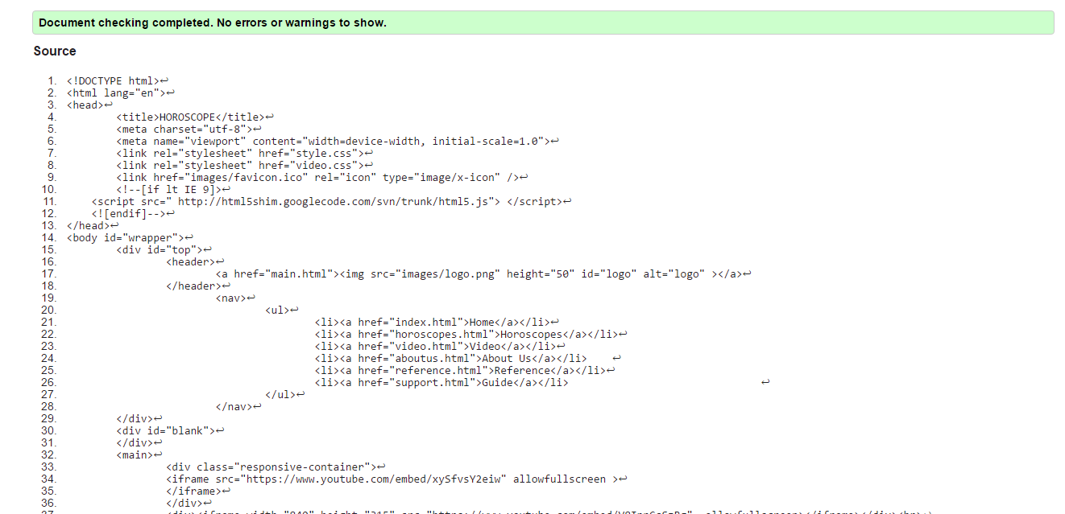

**References (Html)**

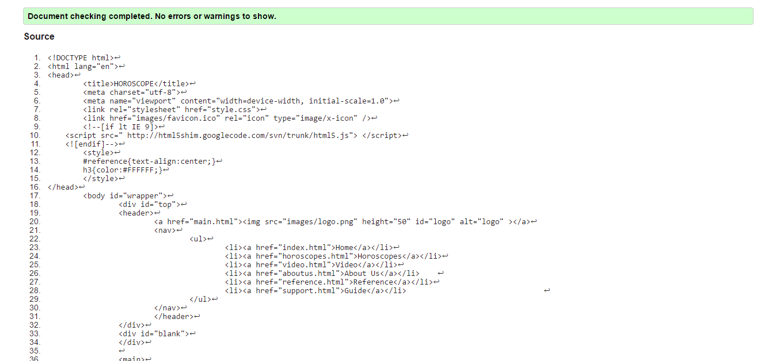

**Support (css)**

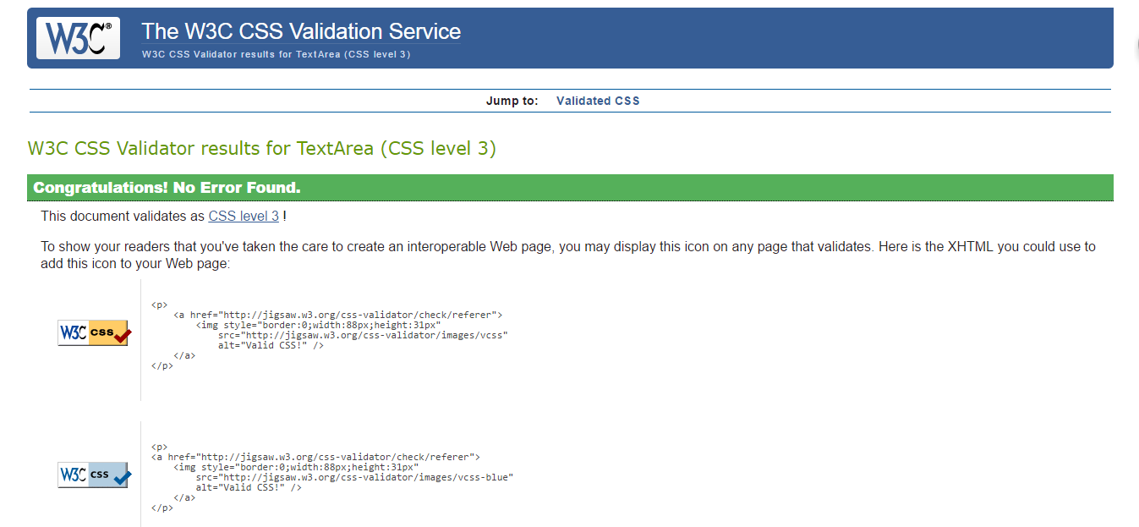

**Support (Html)**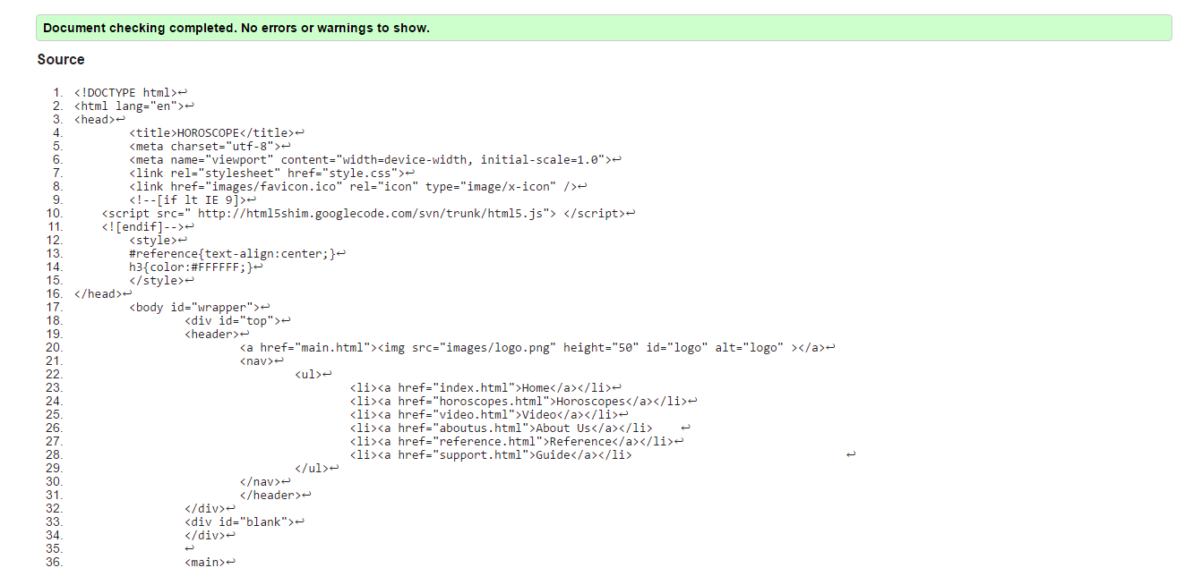

**About us css**

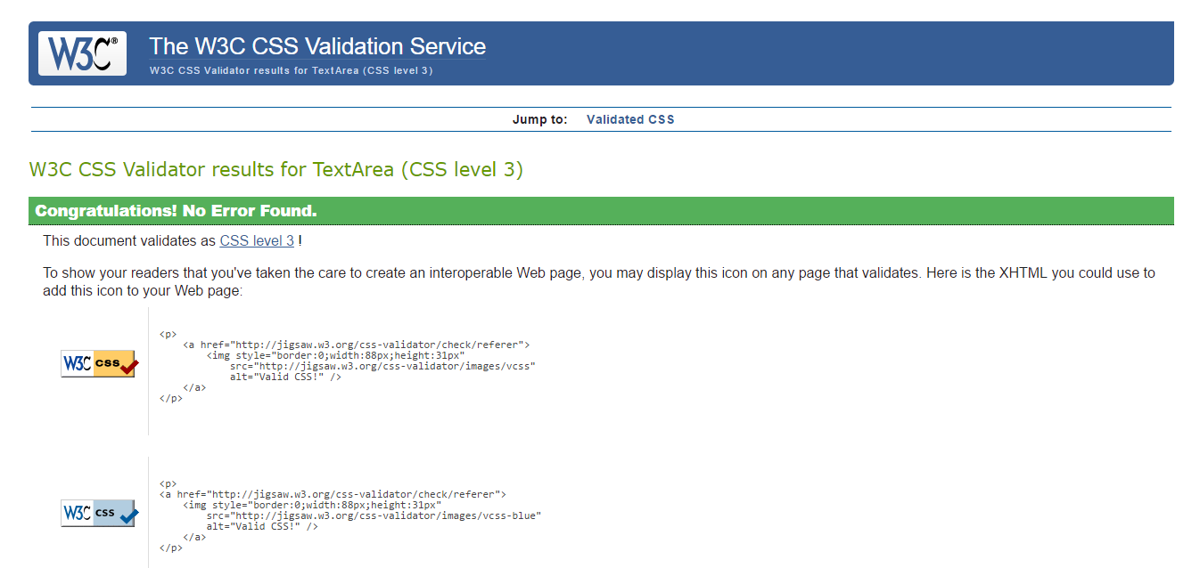

**About us html**

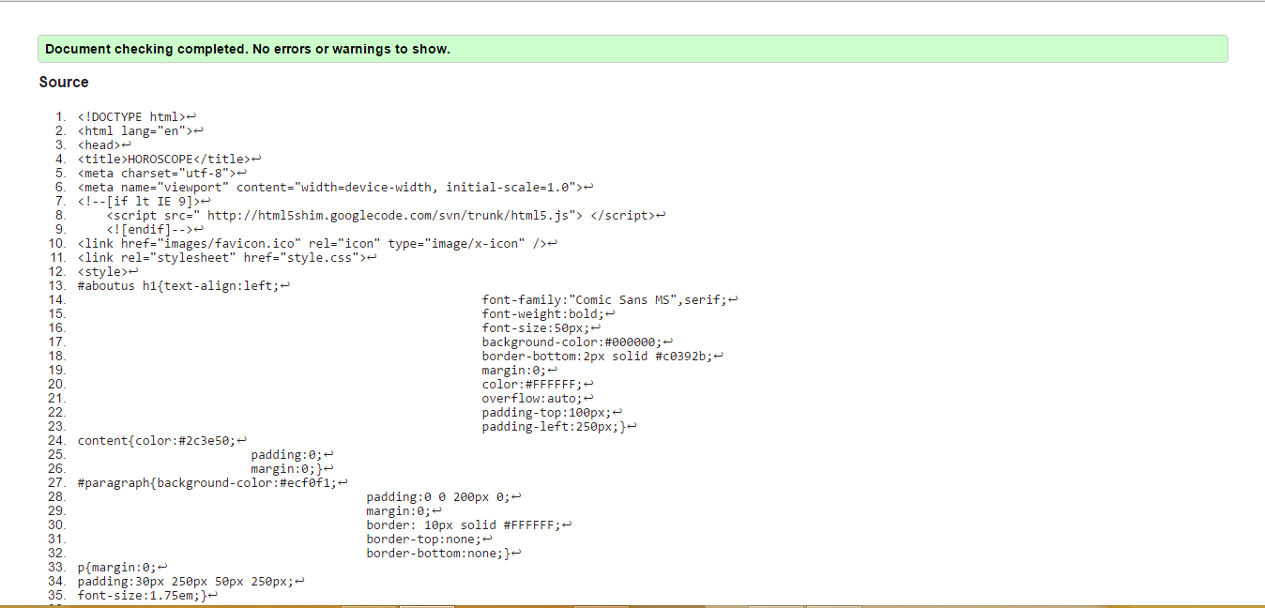

**Style css**

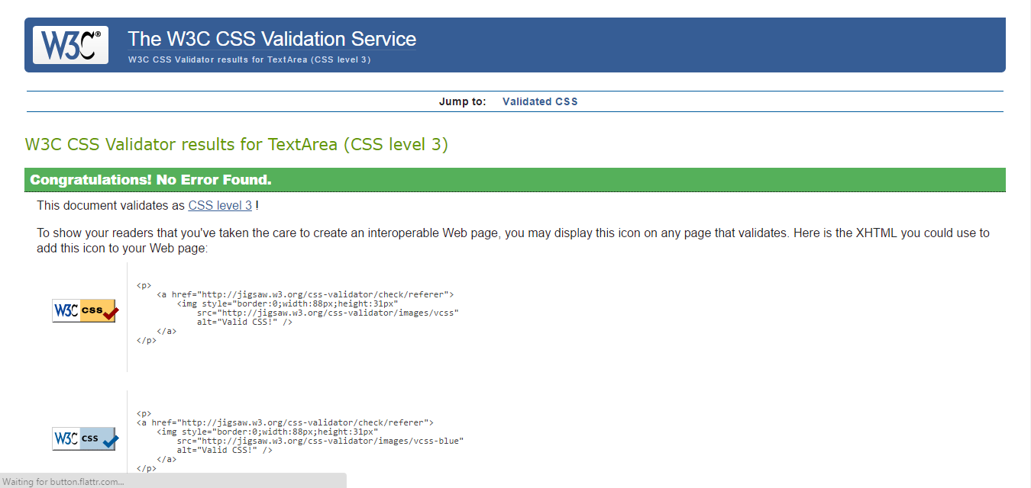

# References

*Astro style*. (n.d.). Retrieved from http://astrostyle.com/

*astrology.com*. (n.d.). Retrieved from http://www.astrology.com/

*horoscope.com*. (n.d.). Retrieved from http://www.horoscope.com/us/index.aspx

*Run away live*. (n.d.). Retrieved from http://runwaylive.com/Horoscope.swf

**MARKING SCHEME**

|  |  |  |  |  |  |  |  |
| --- | --- | --- | --- | --- | --- | --- | --- |
| **CLO Assessed** | **Category** | **10-8** | **7-5** | **4-3** | **2-1** | **Score** | |
| **CLO1** | **Contents** | The site has a well-stated clear purpose and theme that is carried out throughout the site. | The site has a clearly stated purpose and theme, but may have one or two elements that do not seem to be related to it. | The purpose and theme of the site is somewhat vague. | The site lacks a purpose and theme. |  |
| **CLO2** | **Layout / Usability** | The Web site has an exceptionally attractive and usable layout. It is easy to locate all important elements.  White space, graphic elements and/or alignment are used effectively to organize material.  Links for navigation are clearly labeled, consistently placed, allow the reader to easily move from a page to related pages (forward and back), and take the reader where s/he expects to go. | The Web pages have an attractive and usable layout. It is easy to locate all important elements.  Links for navigation are clearly labeled, allow the reader to easily move from a page to related pages (forward and back), and internal links take the reader where s/he expects to go. | The Web pages have a usable layout, but may appear busy or boring. It is easy to locate most of the important elements.  Links for navigation take the reader where s/he expects to go, but some needed links seem to be missing. A user sometimes gets lost. | The Web pages are cluttered looking or confusing.  It is often difficult to locate important elements.  Some links do not take the reader to the sites described.  A user typically feels lost. |  |
| **CLO2** | **Graphics / Design** | Graphics are related to the theme/purpose of the site, are thoughtfully cropped, are of high quality and enhance reader interest or understanding.  Poorly organized  Contain obvious errors; loads slowly | Graphics are related to the theme/purpose of the site, are of good quality and enhance reader interest or understanding.  Organizations somewhat confusing; no obvious errors; loads slowly | Graphics are related to the theme/purpose of the site, and are of good quality.  Good organization;  No errors; loads adequately | Graphics seem  Randomly chosen, are of low quality, OR distract the reader.  Excellent organization;  No errors; loads quickly |  |
| **CLO4** | **HTML Validation** | All pages pass | Most number of pages pass | Less than the required number of pages pass | No pages pass |  |
| **CLO4** | **CSS Validation** | External CSS file is present and passes validation | External CSS file is present and only minor warnings | External CSS file is present but with minor errors | External CSS file is not present or does not pass validation |  |
| **CLO3** | **Responsive Web Design** | intelligently pruning amount of information displayed and;  making adjustment to the design to improve the users' experience while using the application. | There is responsive design being applied but requires some minor changes | There is responsive design being applied but needs some major changes | Unsuitable use of responsive design |  |
| **CLO4** | **Testing** | Tested in variety of browsers and screen sizes  Passed all the requirements in the checklist | Passed most of the requirements in the checklist | Passed almost half of the requirements in the checklist | Passed only few of the requirements |  |
| **CLO3** | **Overall Quality / Additional features** | Website is of high quality. | Website is of good quality. | Website is of mediocre quality. | Website is of poor quality. |  |
| **CLO4** | **Presentation** | Excellent - good eye contact, loud, interesting and able to answer all questions | Good – have eye contact, loud, and able to answer all questions | Average – have eye contact but still return to notes frequently.  Have difficulty in answering questions | Poor – no eye contact, soft and have difficulty in answering questions. |  |
| **CLO4** | **Participation** | Able to meticulously evaluate peers’ work and give constructive feedbacks | Done the evaluation and  able to give constructive feedbacks | Done the evaluation but feedbacks given are poor and not helpful | Evaluation is not complete and feedbacks given are poor. |  |
|  | **Late Submission (-5 per day)** | | | | |  |
|  | **TOTAL (100%)** | | | | |  |